38.34: a) 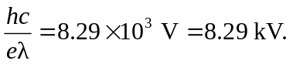 b) The shortest wavelength would correspond to the maximum electron energy, 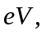 and so 